20170531 NE555 Timer for Rocking Display

[Ebay Link](http://www.ebay.com/itm/Duty-Cycle-and-Frequency-Adjustable-NE555-Square-Wave-Module-DIY-Kit-/332216157436?hash=item4d59a044fc:g:hvAAAOSw8lpZFFJ7)

We are looking for a timer for up to 1 minute. 1 minute is a little challenging for an NE555 circuit. Here we are looking for 30 seconds. The unit we purchased here is for much shorter than that but we are hoping to be able to increase the length of time.

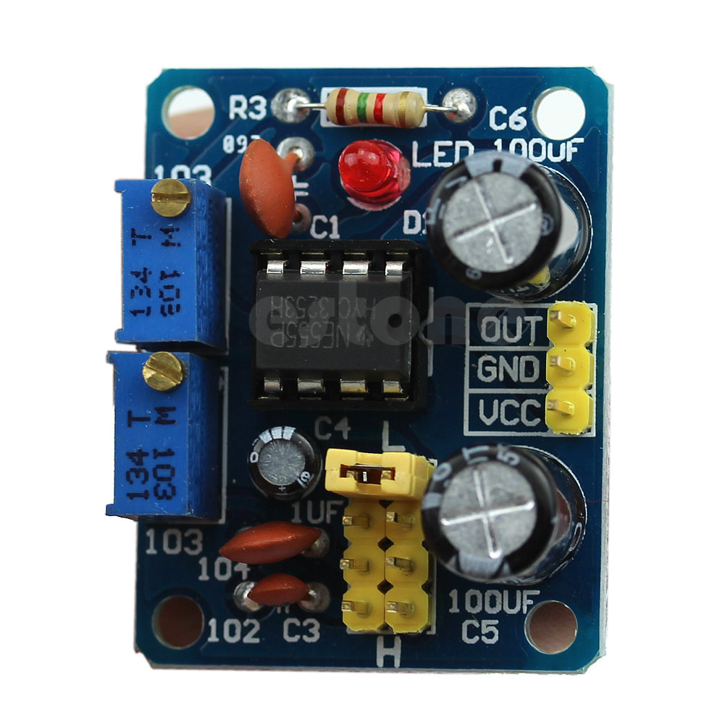

* **100% brand new and high quality**
* Module Scope:
* -Used as a square wave signal generator produces a square wave signal for the experimental development use.
* -Used to generate the square wave signal to drive a stepper motor drive.
* -Produce adjustable pulse for the MCU to use.
* -Generating adjustable pulse to control the associated circuits.
* **A brief description:**
* -Size: 3.5CM * 3.6CM
* -The main chip: NE555;
* -Input voltage: 5V-15VDC. 5V power supply, the output current can about 15MA; 12V power supply, the output current can be so 35MA;
* -Input Current: ? 100MA
* -Output amplitude: 4.2V V-PP to 11.4V V-PP (depending on the input voltage, the output amplitude is not the same)
* -Maximum output current:? 15MA (5V power supply, V-PP greater than 50%), ? 35MA (12V power supply, V-PP greater than 50%)
* **Advantages:**
* -Output with LED indication, there is no output LED quantity (low straightforward, high level LED off relatively low frequency LED flashes);
* -Output frequency range grade optional continuously adjustable output frequency;
* -Low-frequency stall: 1Hz ~ 50Hz
* -IF stall: 50Hz ~ 1kHz
* -In the high-frequency stall: 1KHz ~ 10kHz
* -High-frequency stall: 10kHz ~ 200kHz
* -the output duty cycle can fine-tune the duty cycle and frequency is not adjustable separately adjust the duty cycle will change the frequency
* -the output frequency is adjustable;
* -Cycle T = 0.7*(Ra + 2*Rb)*C
* -Ra, Rb:0-10K adjustable;
* -LF gear C = 0.001UF;
* -IF file C = 0.1UF;
* -In the high-frequency file C = 1UF;,
* -High-frequency gear C = 100UF, the waveform frequency buyers can own calculations.
* NOTE:Output duty cycle can fine-tune the duty cycle and frequency is not adjustable separately adjust the duty cycle will change the frequency
* 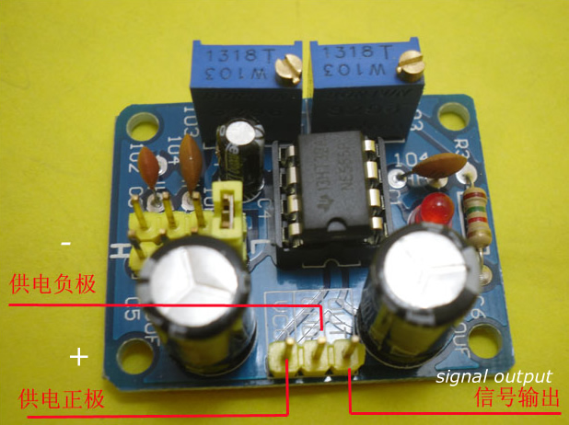
* 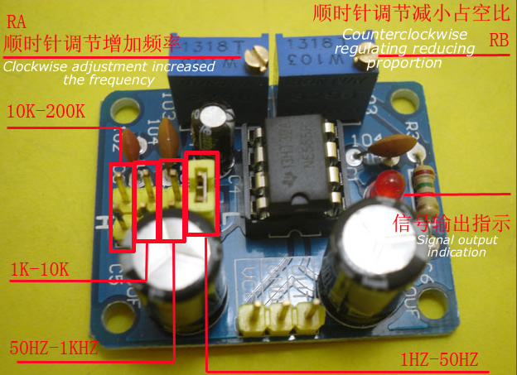
* **1x NE555 Duty Cycle and Frequency Adjustable Module Square Wave**

## DOC SET B

**Features:**

* Size: 31mm * 22mm;
* Main chip: NE555;
* Input Voltage: 5V-15VDC. when power supply is 5V , the output current can be 15MA around;when 12V power supply, the output current can 35MA around;
* Input current: >=100MA
* Output amplitude: 4.2V V-PP to 11.4V V-PP. (Different input voltage, the output amplitude will be different)
* Maximum output current: >=15MA (5V power supply, V-PP greater than 50%),
* >=35MA (12V power supply, V-PP greater than 50%)
* Output with LED indication(low level ,LED will on; high level,LED will off;low frequency, the LED flashes);
* The output requency range is selectable:
  + LF file: 1Hz ~ 50Hz
  + IF file: 50Hz ~ 1kHz
  + High-frequency file: 1KHz ~ 10kHz
  + HF file: 10kHz ~ 200kHz
* The output duty cycle can fine-tune;duty cycle and frequency is not separately adjustable;adjusting the duty cycle will change the frequency;

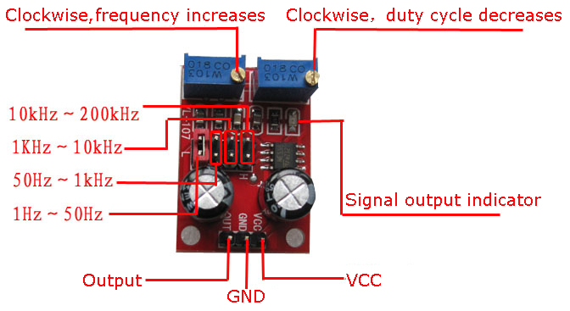

Jumper Position is Reversed From Actual - (1Hz - 50Hz is toward center of board)

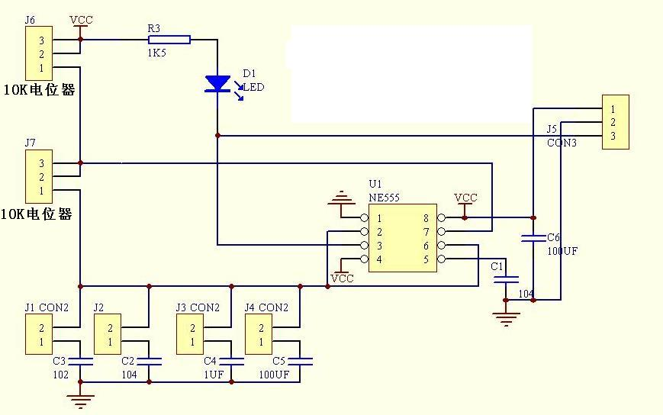

Jumpers 6 and 7 do not exits on our model.

